

Here’s a clean, well-balanced 3-day travel plan for Georgia 🇬🇪 — perfect if you want a mix of culture, nature, and iconic views:

✈️ Day 1: Explore Tbilisi (Old Town + Culture)
🌅 Morning
- Start at Old Tbilisi
  - Walk through colorful streets, balconies, and cafes
- Visit Metekhi Church
- Cross the famous Peace Bridge
🍽️ Lunch
- Try traditional Georgian food:
  - Khinkali (dumplings 🥟)
  - Khachapuri (cheese bread 🧀🍞)
🌇 Afternoon
- Take the cable car to Narikala Fortress
- Walk down to the Abanotubani
🌙 Evening
- Dinner + chill in Rustaveli Avenue

🏔️ Day 2: Mountains Adventure – Kazbegi
🚗 Early Morning Trip (3–4 hrs from Tbilisi)
- Stop at Zhinvali Reservoir
- Visit Ananuri Fortress
🏞️ Afternoon in Kazbegi
- Head to Gergeti Trinity Church
  - One of the most iconic views in Georgia
- Optional: Jeep ride or hike up
🌄 Evening
- Relax in the mountains (perfect sunset 🌅)
- Stay overnight in Kazbegi (recommended)

🌿 Day 3: Nature + Chill OR Wine Region
Option A: Nature & Relaxation
- Visit Dariali Gorge
- Light hiking + riverside views
- Head back to Tbilisi
Option B: Wine Experience 🍷 (Highly Recommended)
- Go to Kakheti
- Visit Sighnaghi (the “City of Love” ❤️)
- Wine tasting + vineyard tours

💡 Quick Tips
- Best time: Spring (Apr–Jun) or Autumn (Sep–Oct)
- Currency: Georgian Lari (GEL)
- Transport: Bolt app works well in Tbilisi
- Tours: Day trips to Kazbegi/Kakheti are easy to book

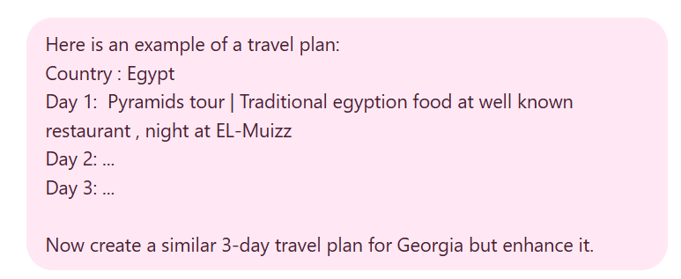

Country: Georgia 🇬🇪

Day 1: Tbilisi Highlights | Culture + City Vibes
Old Town walk in Tbilisi | Cable car to Narikala Fortress | Photos at Peace Bridge | Traditional Georgian lunch (Khachapuri & Khinkali) | Sunset at Mtatsminda Park | Dinner + nightlife on Rustaveli Avenue

Day 2: Kazbegi Adventure | Mountains + Iconic Views
Road trip to Kazbegi via Zhinvali Reservoir & Ananuri Fortress | Scenic drive on Georgian Military Highway | Jeep ride or hike to Gergeti Trinity Church | Mountain sunset + cozy dinner with panoramic views

Day 3: Kakheti Escape | Wine + Chill
Day trip to Kakheti | Explore Sighnaghi | Wine tasting at local vineyards 🍷 | Traditional countryside lunch | Relaxed walk with Alazani Valley views | Return to Tbilisi for a calm evening

✨ Bonus Enhancements
- Add a sulfur bath experience in Abanotubani (super unique 🔥)
- Try Georgian desserts like Churchkhela 🍬
- Perfect mix: City 🏙️ + Mountains 🏔️ + Wine 🍷 = Balanced 3-day trip

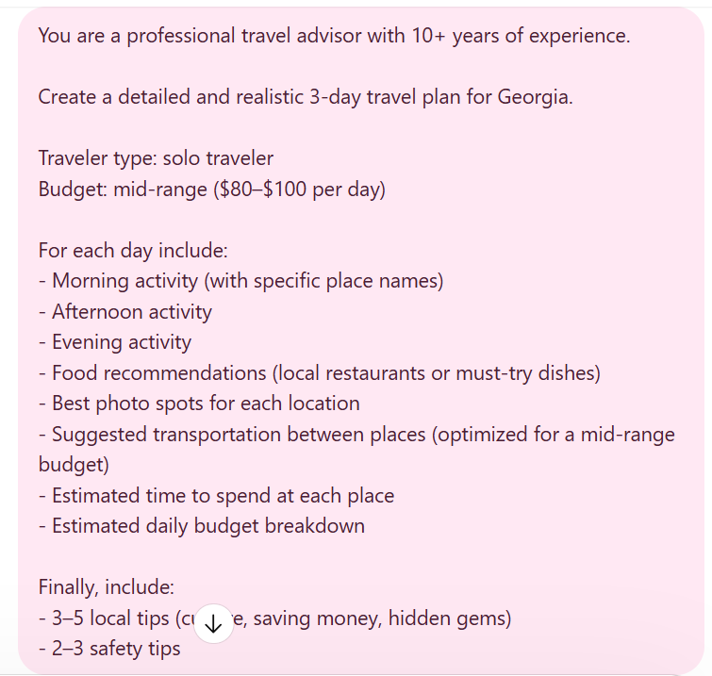

Here’s a professional, realistic 3-day itinerary for Georgia tailored for a solo traveler on a $80–$100/day budget — optimized for experience, logistics, and cost.

🇬🇪 Overview Strategy
- Base yourself in Tbilisi
- Take 2 day trips: Mountains (Kazbegi) + Wine region (Kakheti)
- Use group tours or marshrutka (shared minibus) for best value
👉 Average costs in Georgia:
- Meals: $5–15
- Transport: $3–10 local / $7–20 intercity
- Tours: $40–70

🏙️ Day 1: Tbilisi City Experience (Culture + Chill)
🌅 Morning (3–4 hrs)
📍 Old Town Exploration
- Walk through Old Tbilisi
- Visit Metekhi Church
- Cross Peace Bridge
📸 Photo spots
- Bridge views over Kura River
- Colorful balconies in Old Town
🚶 Transport: Walking (everything close)

🌇 Afternoon (3 hrs)
📍 Views + Landmarks
- Cable car to Narikala Fortress
- Walk down to Abanotubani
📸 Photo spots:
- Panoramic city view from Narikala
- Sulfur bath domes
💰 Cost:
- Cable car: ~$2–3
- Optional sulfur bath: ~$10–15

🌙 Evening (2–3 hrs)
- Walk along Rustaveli Avenue
- Chill café or rooftop dinner
🍽️ Food:
- Must try:
  - Khachapuri 🧀
  - Khinkali 🥟
- Budget meal: $8–12

💰 Day 1 Budget
- Food: $20
- Transport: $5
- Activities: $10
- Accommodation: $40–50
👉 Total: ~$75–85

🏔️ Day 2: Kazbegi Mountains (Iconic Views Day Trip)
🚗 Morning (Travel + Stops | 4–5 hrs total)
Join a group tour (~$50–60) or marshrutka (~$7–10)
Stops:
- Zhinvali Reservoir
- Ananuri Fortress
📸 Photo spots:
- Turquoise reservoir
- Fortress towers
⏱ Travel time:
- ~3–3.5 hrs one way

🏞️ Afternoon (3–4 hrs)
📍 Kazbegi / Stepantsminda
- Jeep or hike to Gergeti Trinity Church
📸 Photo spots:
- Church with Mount Kazbek backdrop (🔥 iconic)
💰 Cost:
- Jeep ride: $15–20

🌙 Evening (Return + Dinner)
- Return to Tbilisi (~7–9 PM)
- Casual dinner near hotel
🍽️ Try:
- Kharcho (Georgian stew)
- Local wine 🍷

💰 Day 2 Budget
- Tour/transport: $50–60
- Food: $20
- Activities: $15
👉 Total: ~$85–95

🍷 Day 3: Kakheti Wine Region (Relax + Culture)
🚗 Morning (2–2.5 hrs)
Travel to Kakheti
- Marshrutka: ~$6–8
- Or group wine tour: ~$40–60

🌿 Afternoon (4–5 hrs)
📍 Sighnaghi + Wineries
- Explore Sighnaghi
- Wine tasting (2–3 wineries)
📸 Photo spots:
- Alazani Valley views
- City walls & rooftops
💰 Wine tasting:
- ~$20–25

🌙 Evening (Return + Chill)
- Return to Tbilisi
- Light dinner or café
🍽️ Try:
- Churchkhela (Georgian sweet)
- Lobio (bean stew)

💰 Day 3 Budget
- Transport/tour: $40–60
- Food: $20
- Activities: $20
👉 Total: ~$80–95

💡 Local Tips (from experience)
- Use Bolt instead of taxis → cheaper + safer (~$2–5 rides)
- Avoid exchanging money at the airport → worse rates (common traveler tip)
- Join group tours as a solo traveler → best value + social
- Georgian meals are big → share portions to save money
- Visit sulfur baths early morning → less crowded

⚠️ Safety Tips
- Roads to Kazbegi are mountainous → choose experienced drivers or tours
- Avoid unofficial taxis → always use apps or agree price first
- Keep cash (GEL) → small places don’t accept cards

